**TERM PROJECT**

**Akhilesh Kumar**

**CSE 621**

**Instructor: Dr. Ann E. Sobel**

**ROYAL SERVICE STATION SOFTWARE SYSTEM**

1. **Product Perspective:**

Basically, the big Service Stations are a part of large system. I believe my Royal Service Station is also a part of large system. But there is no reason it cannot operate as a self-contained, independent unit. For my project I would treat it as a part of larger system.

1. **Product Functions**

There are three major functions that the system provides its customers.

1. Refueling: Customers can add fuel to their tank.
2. Vehicle Maintenance: Customers can have their vehicle repaired.
3. Parking: Customers can park their vehicles (car, motorcycle or truck).

Finer details of what the system does is listed below

* The system must track the bills, the product and services.
* The system should calculate the bill based on the fuel type.
* The system to track credit history and payments overdue, personal check and cash.
* The system must provide customer with the option of being billed or sent monthly paper bill.
* The system must handle the data requirements for interfacing with other systems
* The system should be able to calculate the 5% local tax on all the purchases.
* The system provides the parking by daily, weekly or monthly basis.
* The station manager should be able to control inventory.
* The part ordering system must return the delivery date after the correct input.
* The fuel ordering system must also return the delivery date after the order.
* The system will send periodic messages to customers.
* Customers can rent parking space in the station parking lot.
* The system maintains a repository of account information.
* The station manager should be able to view monthly report summarizing how many parking spaces were available or occupied.
* The station manager must be able to review accounting information on demand.
* The station manager should be able to enter or change prices.
* He should be able to give discounts to customers he wants.
* The system will automatically notify the owners of dormant accounts.

1. **User Characteristics:**

The station manager Manny acts like the administrator of the system. He should be able to enter the price or change the price of the products. He is also capable of giving discounts to customers which may vary customer to customer. Station manager should also be able to view the monthly report summarizing the availability of the parking spaces. The station manager must be able to review accounting information upon demand. Other users that the system will like to attract are those who own a vehicle. The system is also capable of interacting with other systems.

The educational requirement is not very high. Users should just be able to read the letters and digits. Since the users need to fill the gas tank they should be able to understand what amount they are going to fill. Otherwise no educational or technical expertise is required.

**d/e) Constraints and the Assumptions, dependencies**

The major constraints of the system that I can think of are the external factors. Interface with the outside world is the main factor that can affect the system. Change in functionality for eg. if we want to include some extra functions in the system, say for example if I would like to open a restaurant for the customers, then it might affect the SRS and may require an overall change in the software to include the new sub-system. Some other possible constraints my include increase in the structure of the parking space which will force the designer to make changes in the software to include new function to calculate the parking space according to the new structure. These changes are rare but possible. The behavioural change in any object might also affect the system. For eg. If instead of the petrol the vehicle start using compressed natural gas then the system should also be changed according to the changes. A change in long-lived information structure might also be one of the possible dependencies for the system. For eg. If the credit card system make some changes in their system then our system also needs to be modified accordingly. A change in the contact information of the person may also require some changes to be done in the system. These are few possible constraints/dependencies of the system.

**DIAGRAMs FOR THE SYSTEM AND VARIOUS COMPONENTS WITH EXPLANATION**

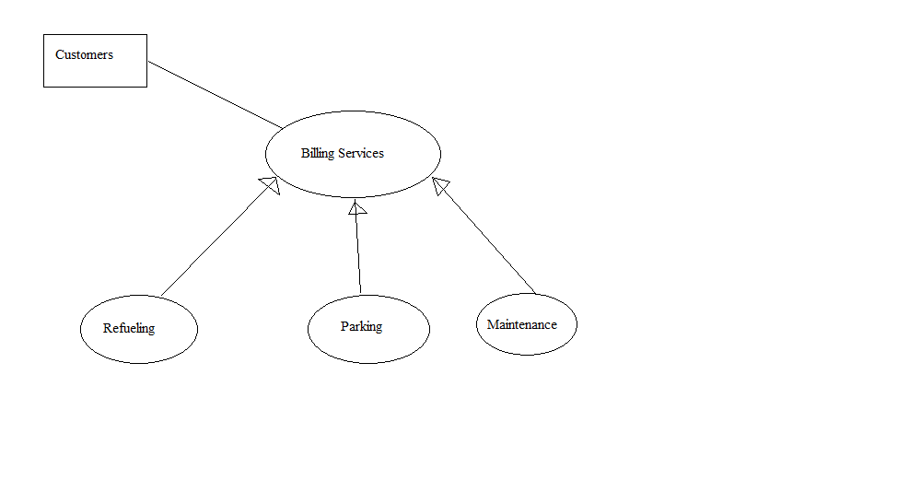

**HIGH LEVEL DESCRIPTION OF ROYAL SERVICE STATION**

**Explanation for the Diagram**

The High level description above shows the interaction of the customers and the various services provided by the Royal Service Station. The diagram above shows the various services provided by the system and how the customers interact with the billing system.

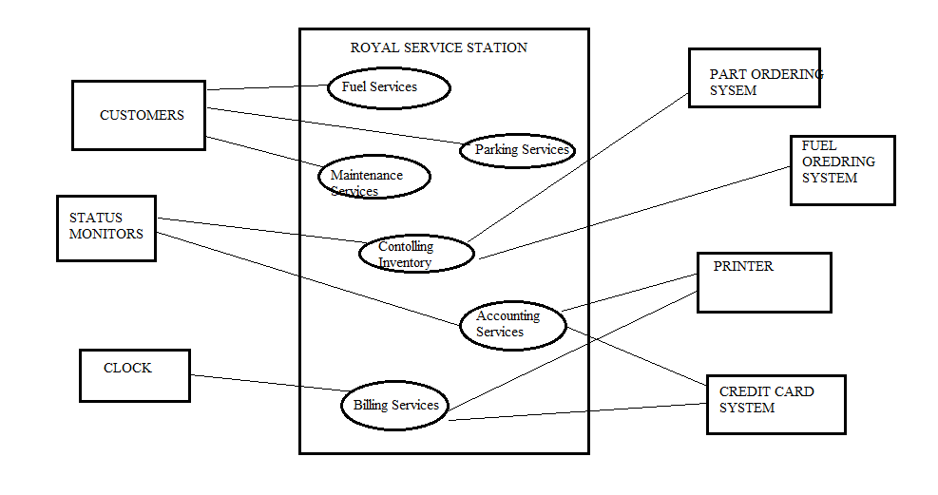

**Intermediate level description of the Royal Service Station Software**

**Explanation of the diagram**

The above diagram is the user case diagram for the Royal Service Station. This displays how the various users of the system interact. The customers can take advantage of the Refueling System or the Parking services or the Maintenance services. They can refuel their vehicle, or park their vehicle in the parking lot provided by the system or they can get their vehicles repaired. The status monitors are the people who look after the inventory and the accounts and check if there is any issue. If the inventory is low then they can order new low stocks through the part ordering system or the fuel ordering system. The accounting services prints the bill and interacts with the credit card system to check the details. A warning message is sent to those who don’t pay their monthly bills on time.

**UML DIAGRAM:**

A possible UML diagram for the system is given below. It shows the various methods and the relation between the different possible classes of the system.

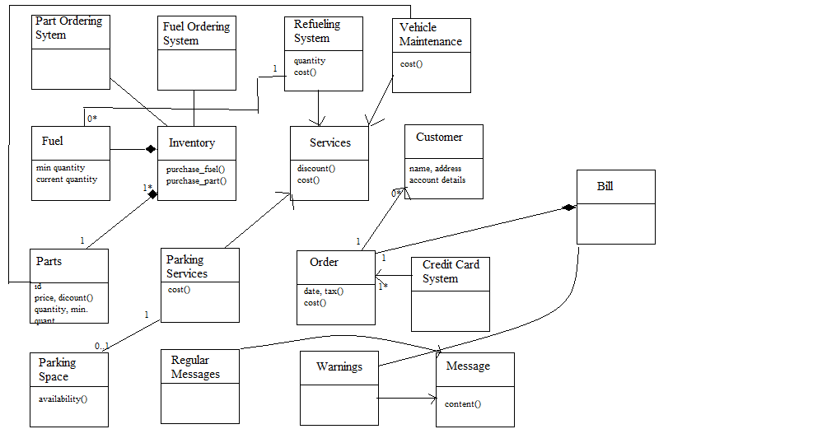

There is a Service class. The Refueling System, Vehicle Maintenance and the Parking System all inherit from the Service class. The inventory is an aggregate of the Fuel and the Parts. A bill must of 1 or more orders. The Parking space checks the availability and calculates the cost using the parking services class. Warnings and the Periodic messages inherit from the Message superclass. Since both are a king of message so they have common attribute. If the customer makes an order and pays in cash or by check then the order class calculates the cost. If he pays by credit card then the Credit Card System will verify it. And also for each bill there can be one or more purchases.

**STATE CHARTS:**

**STATE CHART FOR ORDERING SYSTEM:**

This state chart will work for both the Fuel and Part Ordering system. If the state is normal then it will keep on updating the amount of stock left. Once it goes below the threshold quantity then it would enter the ordering state. It will increase the stock by ordering the new stock and once it is more than the threshold quantity it goes into the normal state.

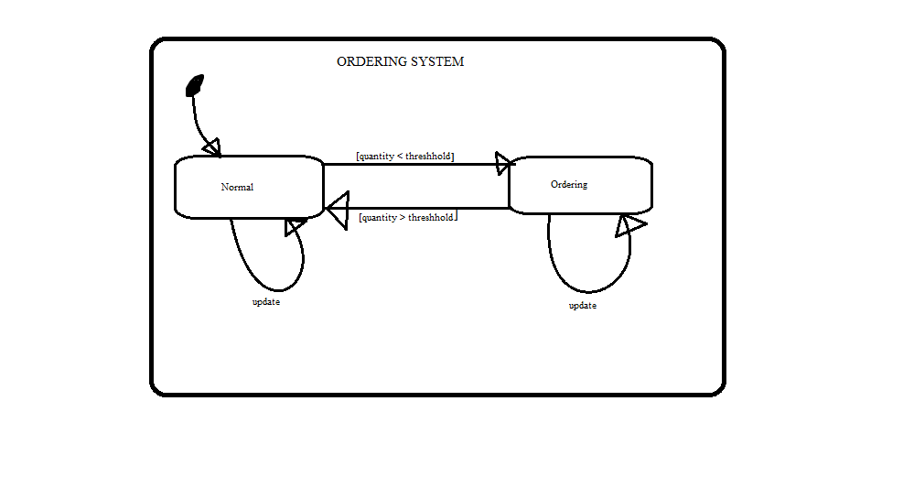

**STATE CHART FOR CREDIT CARD SYSTEM**

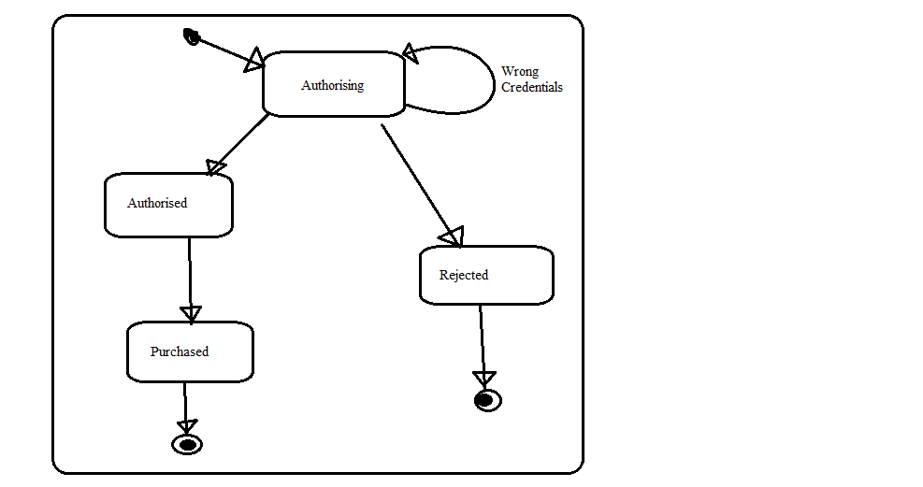

The Credit Card Authorisation is shown in the diagram. The start state is the Authorizing state. If someone enters a wrong credentials then he remains in that state itself. If the credential is okay then he is authorized to pay and after the payment is done the purchase is made and the system enters a final state. If the authorization is unsuccessful then he enters a rejected state and then into the final state.

**CONCLUSION:**

I believe I have recognised the various components of the system software and their functions. I also think that have figured out dependency of one sub-system with the other sub-systems. In the near future I would try to complete the project by using the Z- Model.